School of Humanities,
Languages & Social Sciences
University of Salford
Salford M5 4WT
United Kingdom
t: +44(0)161 295 5990
f: +44(0)161 295 5335
e: Enquiries-HuLSS@salford.ac.uk

Direct line: 0161 295 3597
Email: S.Thurston@salford.ac.uk
24 October 2012
To whom it may concern:
REFERENCE FOR KALYAN BHATTACHARYA
I first met Kalyan about a year and a half ago when he approached me to ask for my opinion about some original poetry that he had been working on. Kalyan struck me as the archetypal 'Renaissance Man'. With a background in physics and engineering, he is also fascinated by literature and philosophy and engages in moral and political issues with genuine passion. I have come to look forward to our meetings as impromptu humanistic debates as much as creative tutorials. As a creative writer in his second language, Kalyan demonstrates considerable clarity and articulacy in his poetry and handles poetic form in an informed and effective way. It is due to my experience of Kalyan in conversation and as a poet that I can vouch for his communicative abilities in written and spoken English.
As I have not worked directly with Kalyan as a tutor at the University of Salford it is harder for me to reflect in great detail about his overall academic achievements and what they might reveal about his aptitude for teaching. That said, I do feel that his kind, generous and attentive character would equip him for certain key aspects of a teacher's role, and I believe that he is strongly committed to the social mission of the profession. His clear-eyed moral and intellectual view of the world is refreshingly unjaded and I think he would be a hugely positive influence in a learning environment – capable of serious play and seeing the human comedy in any difficult situation.
I wholeheartedly recommend Kalyan to you for serious consideration and strongly advise that you take the opportunity to interview him in person to hear for yourself what he has to offer. I believe he has a lot to give.
Yours faithfully,
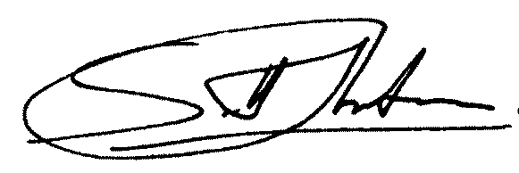
Dr Scott Thurston, Senior Lecturer in English and Creative Writing

